

Dr. Gregg, Ford inc.
2024-07-28
Dr. Ford
PSC 7906, Box 4841, APO AA 97091
Phone: 3457429814
Fax: 614871548

Re: Melissa, Taylor
PHN: 3201620250
Birthdate: 04-Apr-1978
Address: 666 Walters Park Apt. 337, Hannahside, PA 89428
Patient number: 1058026287

To Whom It May Concern:

This is a medical letter to state the above patient is pregnant with expected delivery date of 29-Mar-2025. Hoping this information is satisfactory for your requirements.

Thank you.

Sincerely,
Dr. Gregg, Ford
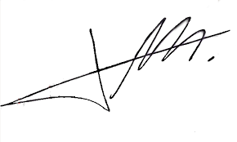
FRCS© NCMP
Clinical Assistant Professor, UBC
Department of Obstetrics and Gynecology SMH

